Ques1: - Basic Commands of Linux.
Answer: -
Command 1: pwd
The pwd command is used to display the location of the current working directory.
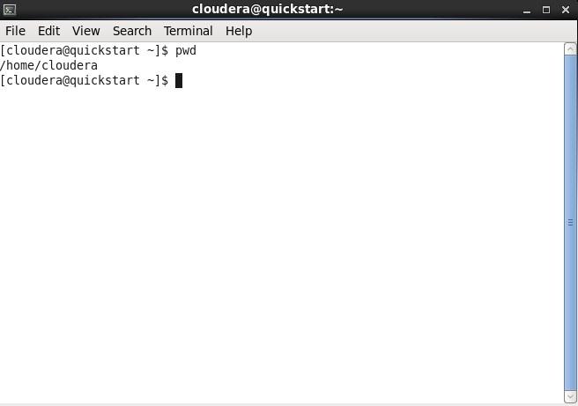
Command 2: mkdir
The mkdir command is used to create a new directory under a directory.
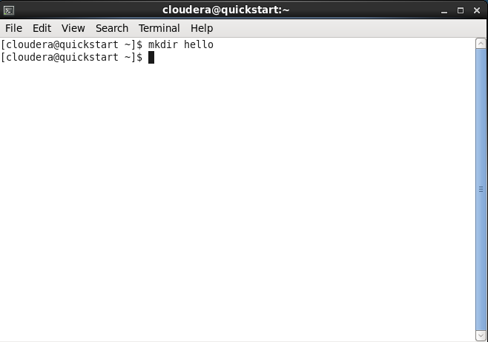
Command 3: rmdir
The rmdir command is used to delete a directory.
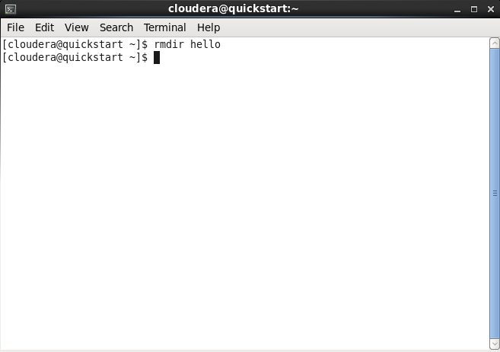
Command 4: ls
The ls command is used to display a list of content of a directory.
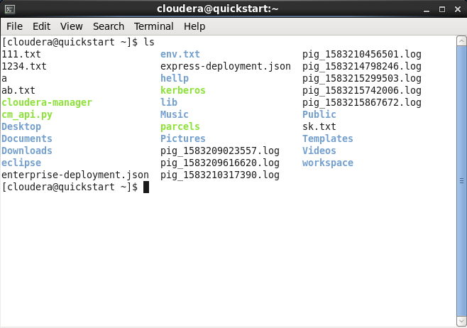

Command 5: cd
The cd command is used to change the current directory
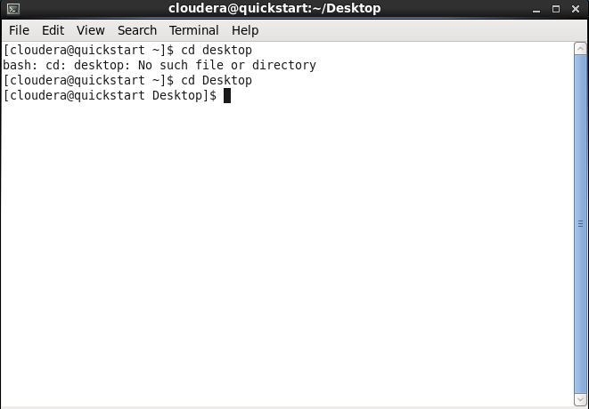
Command 6: touch
The touch is used to create empty file. We can create multiple empty files by executing it once.
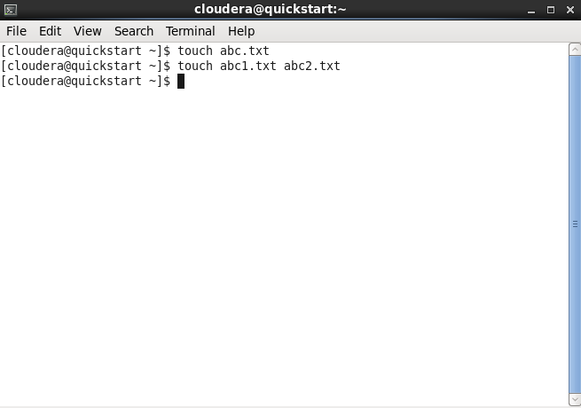
Command 7: cat
The cat command is used to create a file, display content of a file, copy the content of one file to another file, and more.
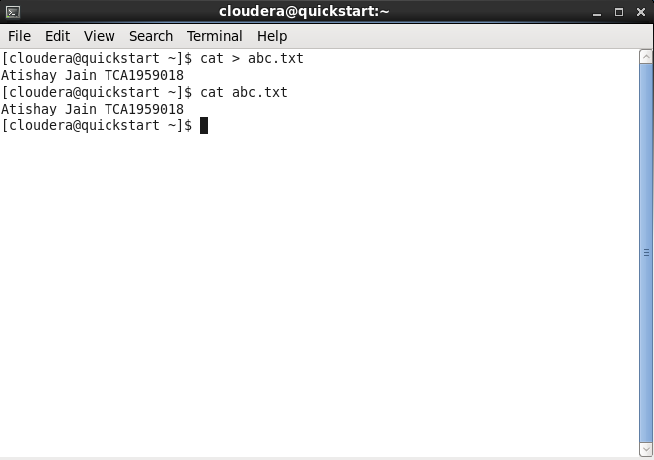
Command 8: rm
The rm command is used to remove a file.
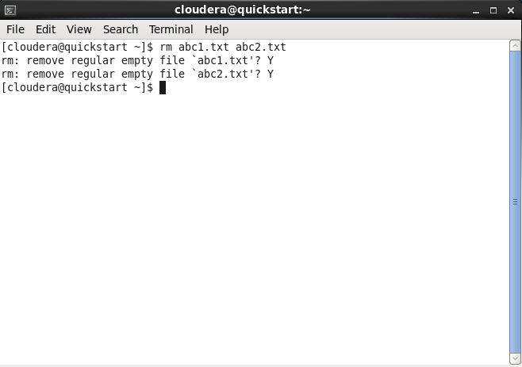
Command 9: cp
The cp command is used to copy a file or directory
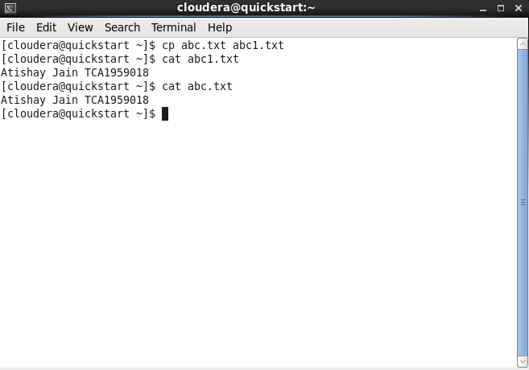
Command 9: mv
The mv command is used to move a file or directory from one location to another location.
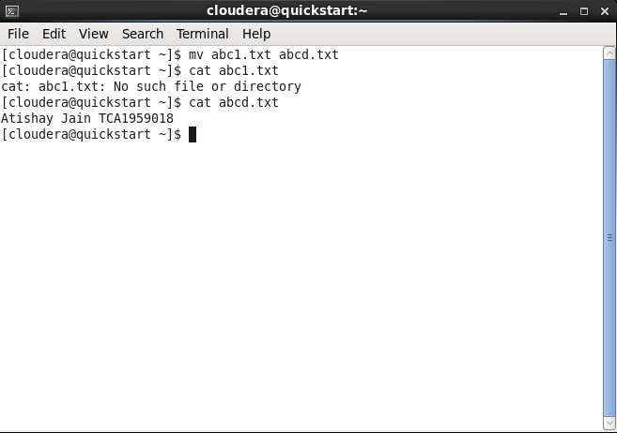
Command 10: rename
The rename command is used to rename files. It is useful for renaming a large group of files.
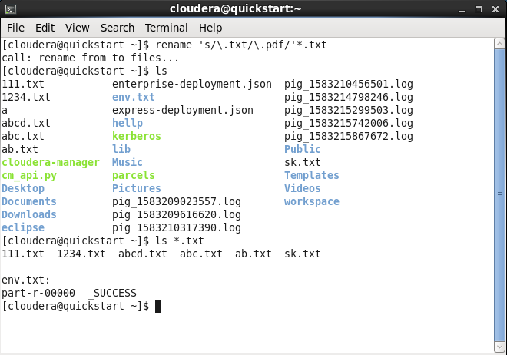
Command 11: head
The head command is used to display the content of a file. It displays the first 10 lines of a file.
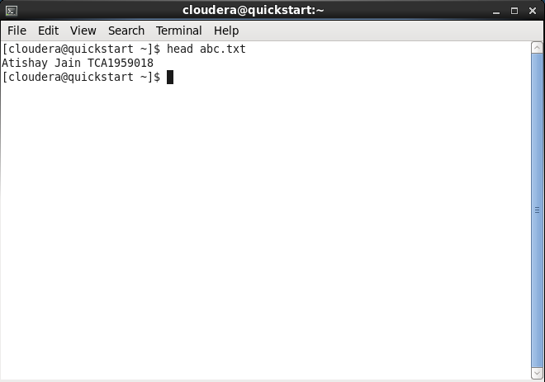
Command 12: tail
The tail command is used display the last 10 lines of a file. It useful for reading the error message.
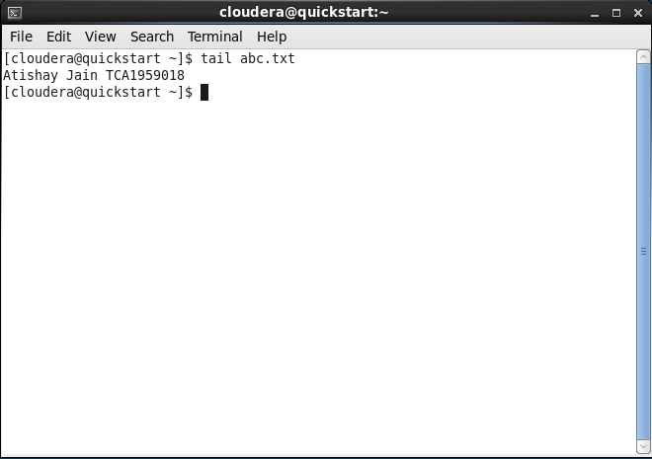
Command 13: more
The more is quite similar to the cat command, as it is used to display the file content in the same way that the cat command does. The only difference between both commands is that, in case of larger files, the more command displays screenful output at a time.
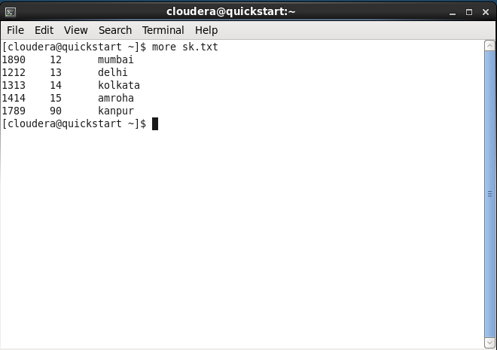
Command 14: less
The less command is similar to the more command. It also includes some extra features such as 'adjustment in width and height of the terminal.' Comparatively, the more command cuts the output in the width of the terminal.
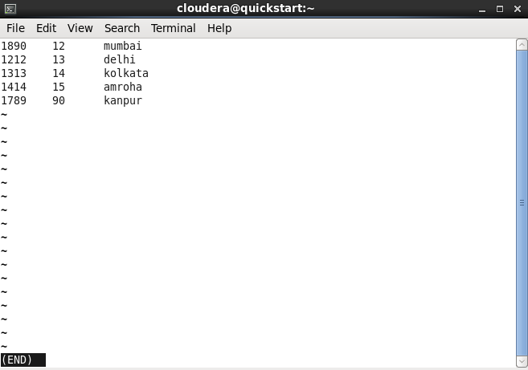
Command 15: su command
The su command provides administrative access to another user. In other words, it allows access of the Linux shell to another user.
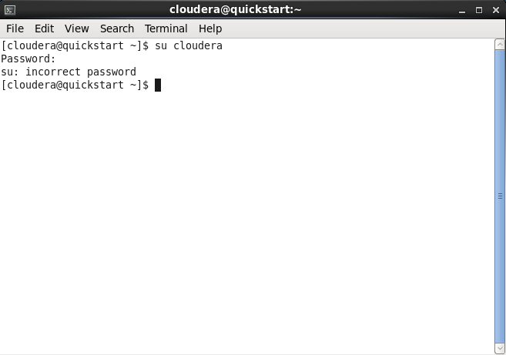

Command 16: id
The id command is used display the user ID and group ID.
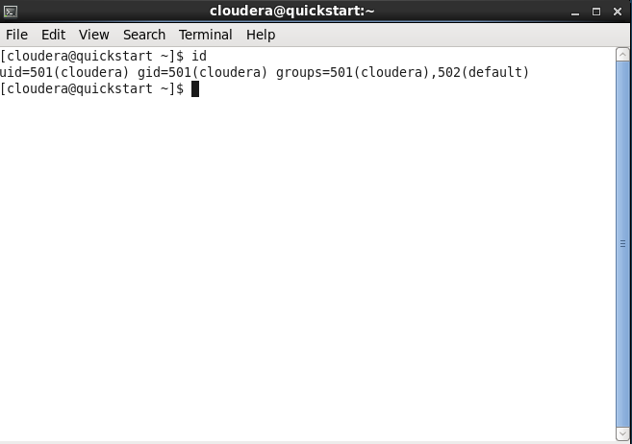
Command 17: useradd
The useradd command is used to add or remove a user on a Linux server.
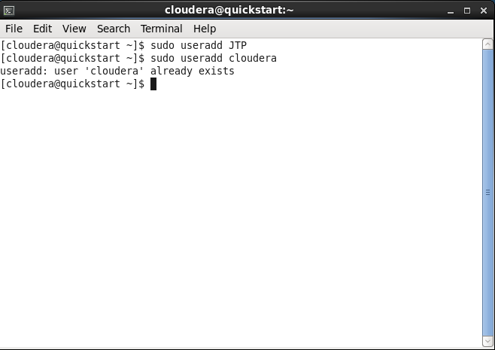
Command 18: passwd
The passwd command is used to create and change the password for a user.
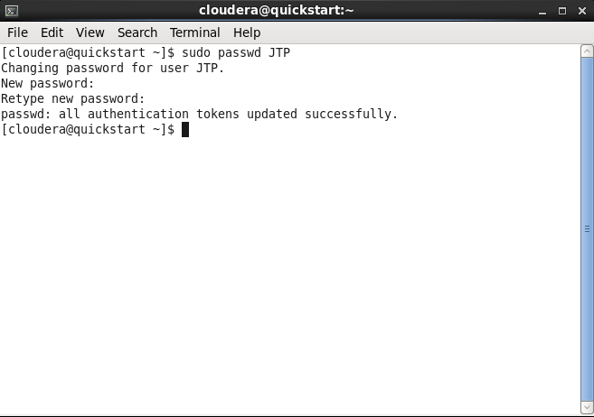
Command 19: groupadd
The groupadd command is used to create a user group.
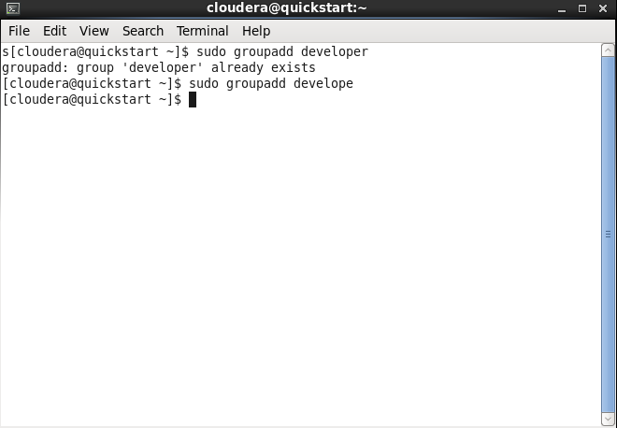
Command 20: cat
The cat command is also used as a filter. To filter a file, it is used inside pipes.
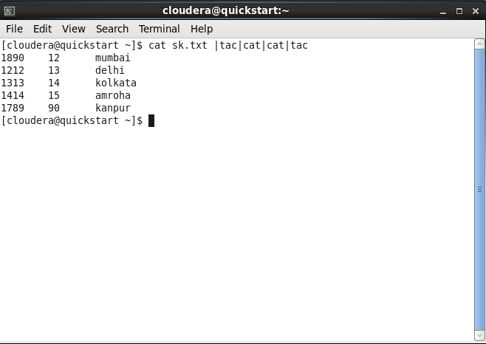
Command 21: cut
The cut command is used to select a specific column of a file. The '-d' option is used as a delimiter, and it can be a space (' '), a slash (/), a hyphen (-), or anything else. And, the '-f' option is used to specify a column number.
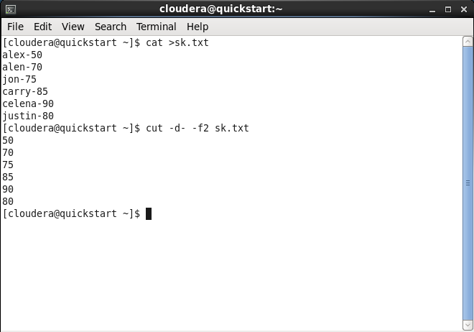
Command 22: grep
The grep is the most powerful and used filter in a Linux system. The 'grep' stands for "global regular expression print." It is useful for searching the content from a file. Generally, it is used with the pipe.
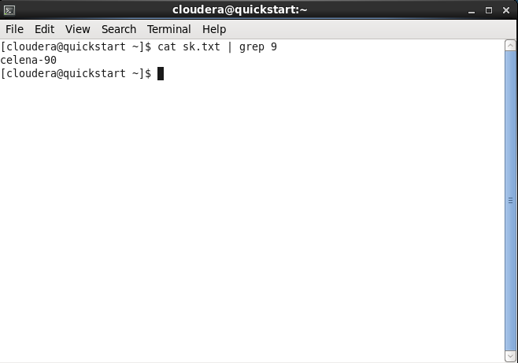
Command 23: tr
The tr command is used to translate the file content like from Lower to Upper case.
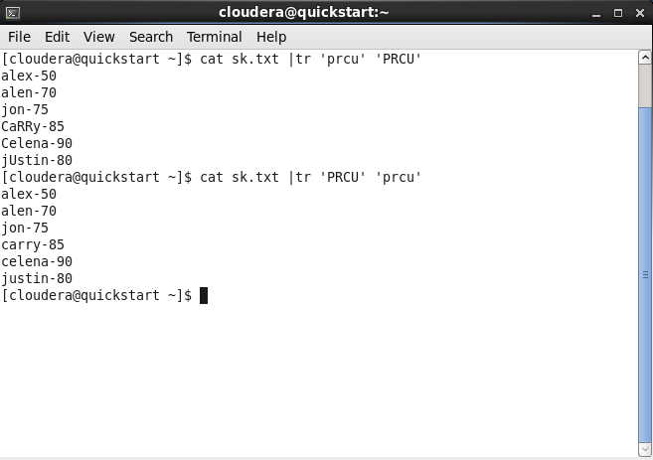

Command 24: uniq
The uniq command is used to form a sorted list in which every word will occur only once.
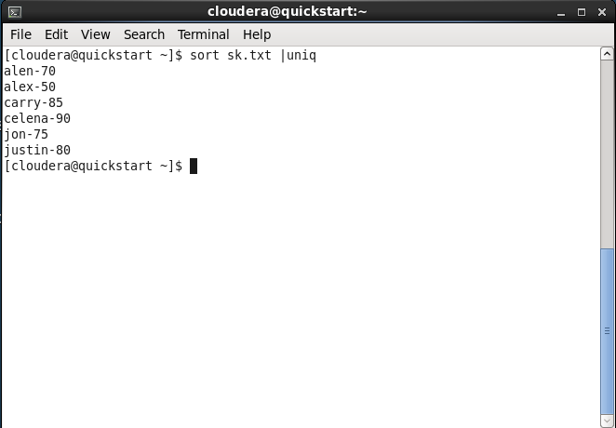
Command 25: wc
The wc command is used to count the lines, words, and characters in a file.
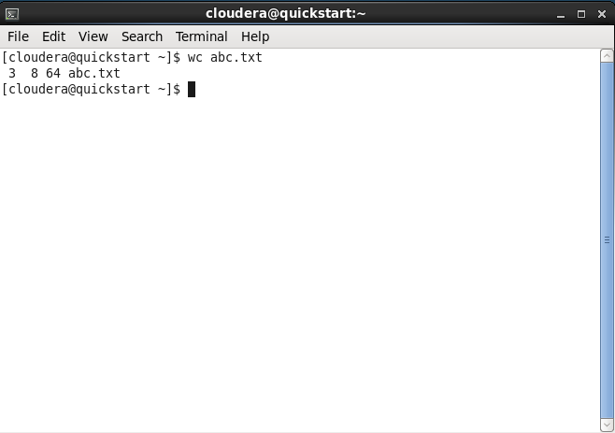
Command 26: od
The od command is used to display the content of a file in different s, such as hexadecimal, octal, and ASCII characters.
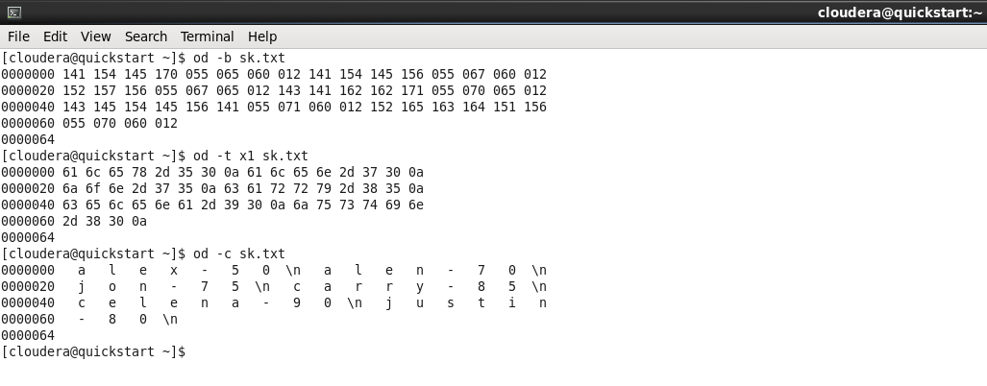
Command 27: sort
The sort command is used to sort files in alphabetical order.
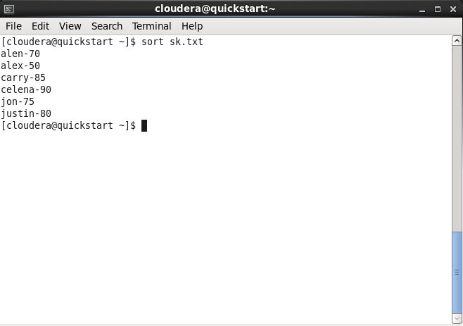
Command 28: gzip
The gzip command is used to truncate the file size. It is a compressing tool. It replaces the original file by the compressed file having '.gz' extension.
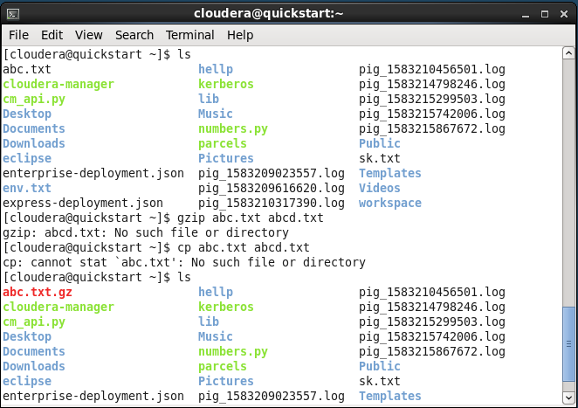
Command 29: gunzip
The gunzip command is used to decompress a file. It is a reverse operation of gzip command.
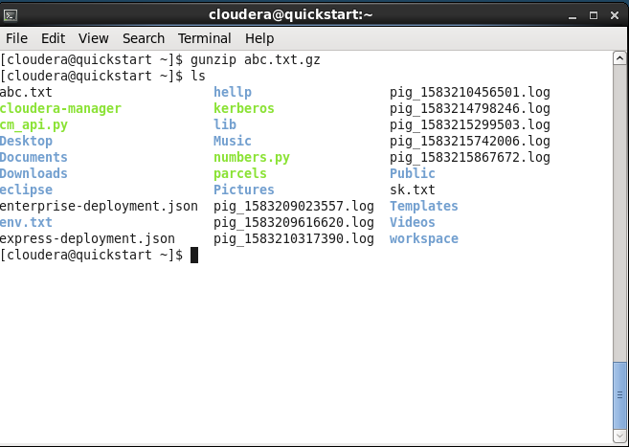
Command 30: find
The find command is used to find a particular file within a directory. It also supports various options to find a file such as byname, by type, by date, and more.
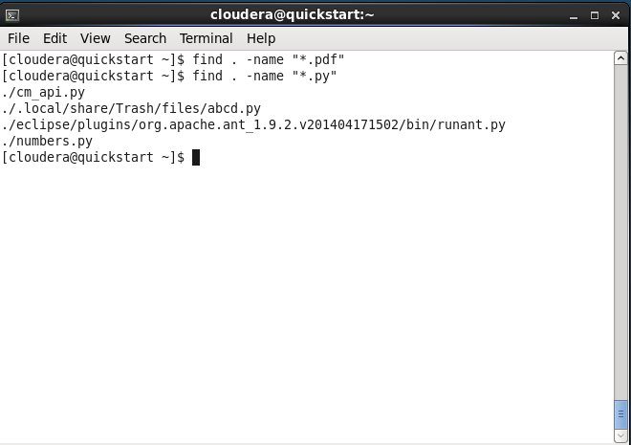
Command 31: locate
The locate command is used to search a file by file name. It is quite similar to find command; the difference is that it is a background process. It searches the file in the database, whereas the find command searches in the file system. It is faster than the find command. To find the file with the locates command, keep your database updated.
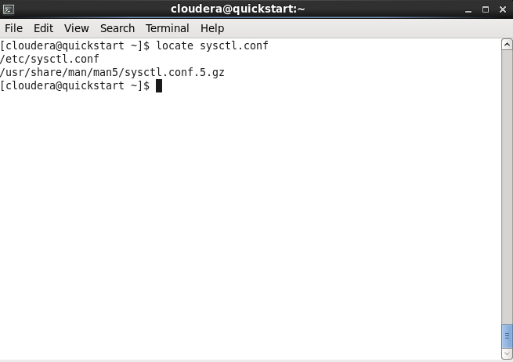
Command 32: date
The date command is used to display date, time zone, and more.
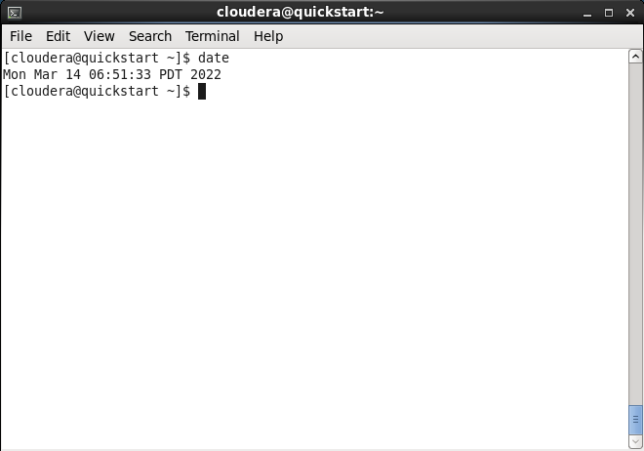
Command 33: cal
The cal command is used to display the current month’s calendar with the current date highlighted.
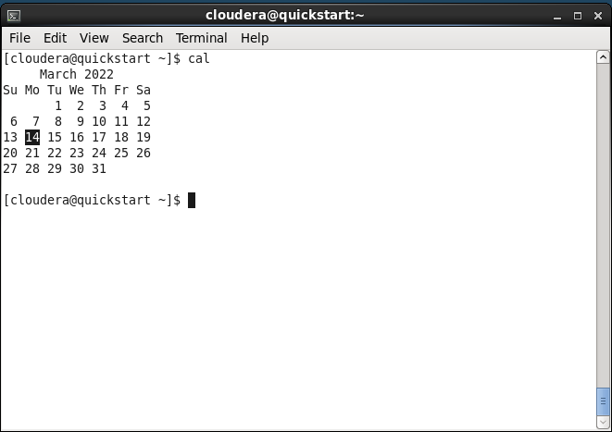
Command 34: sleep
The sleep command is used to hold the terminal by the specified amount of time. By default, it takes time in seconds
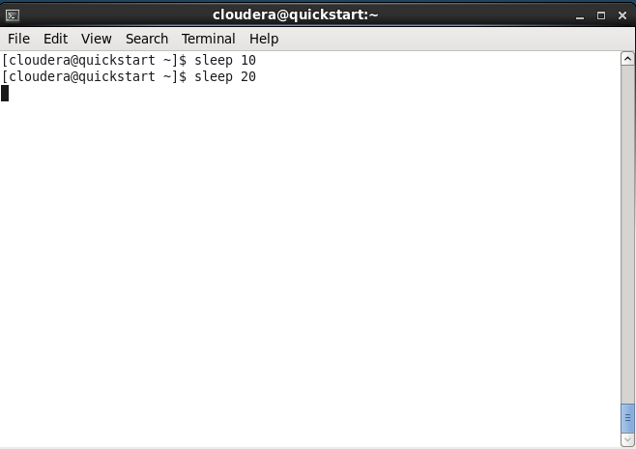

Command 35: time
The time command is used to display the time to execute a command.
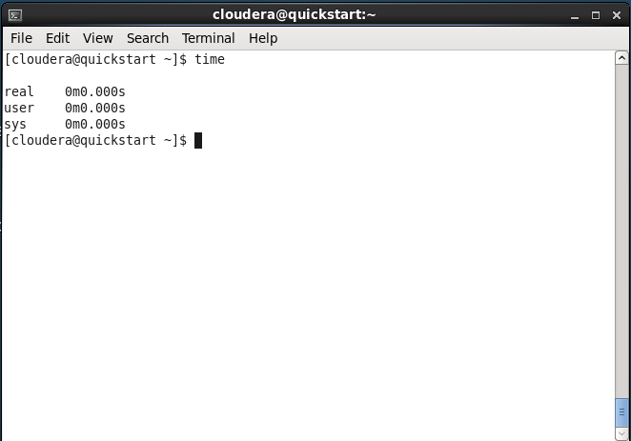
Command 36: zcat
The zcat command is used to display the compressed files.

Command 37: df
The df command is used to display the disk space used in the file system. It displays the output as in the number of used blocks, available blocks, and the mounted directory.
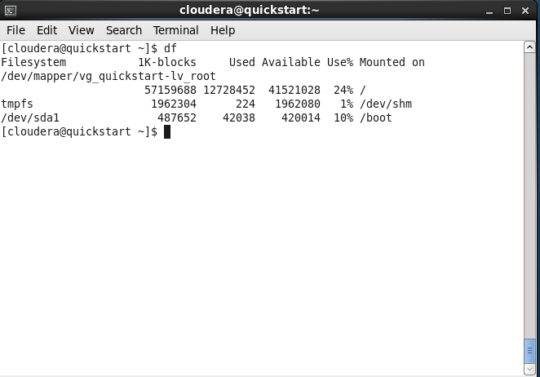

Command 38: mount
The mount command is used to connect an external device file system to the system's file system.
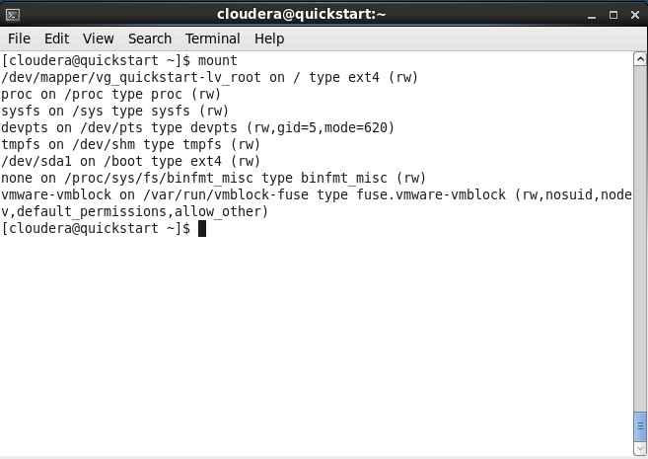
Command 39: exit
The exit command is used to exit from the current shell. It takes a parameter as a number and exits the shell with a return of status number.
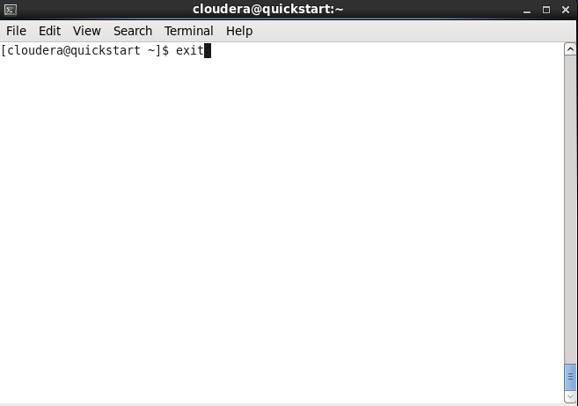
Command 40: clear
Linux clear command is used to clear the terminal screen.
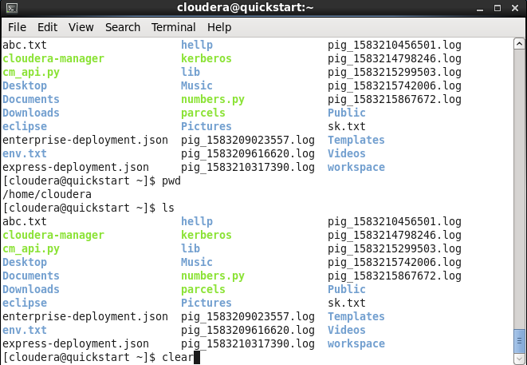

Command 41: ip
The ip command is an updated version of the ipconfig command. It is used to assign an IP address, initialize an interface, disable an interface.
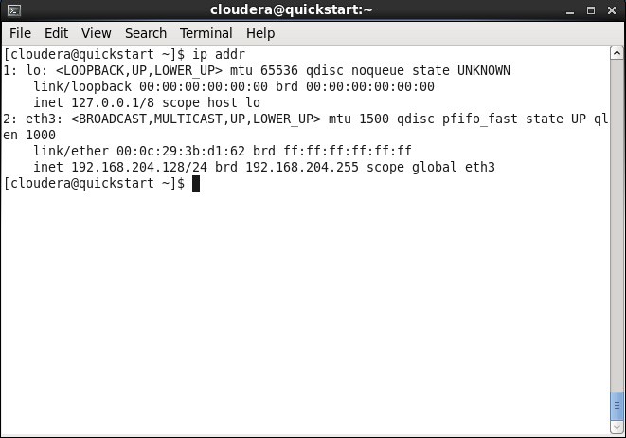
Command 42: ssh
Linux ssh command is used to create a remote connection through the ssh protocol.
Command 43: mail
The mail command is used to send emails from the command line.
Command 44: ping
The command is used to check the connectivity between the two nodes, that is whether the server is connected. It is short form of “Packet Internet Groper”.
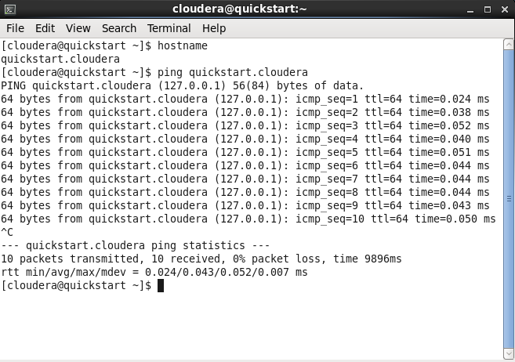

Command 45: host
The host command is used to display the IP address for a given domain name and vice versa. It performs the DNS lookups for the DNS Query.
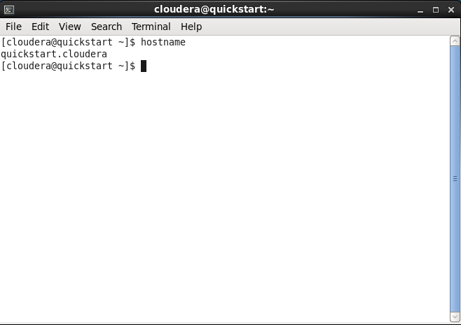

Command 46: chmod

chmod to make a file executable and to change the permissions granted to it in Linux.

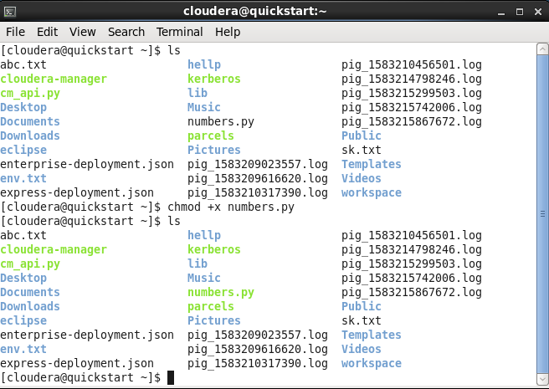

Command 47: uname

The uname command is used to show the information about the system your Linux distro is running.

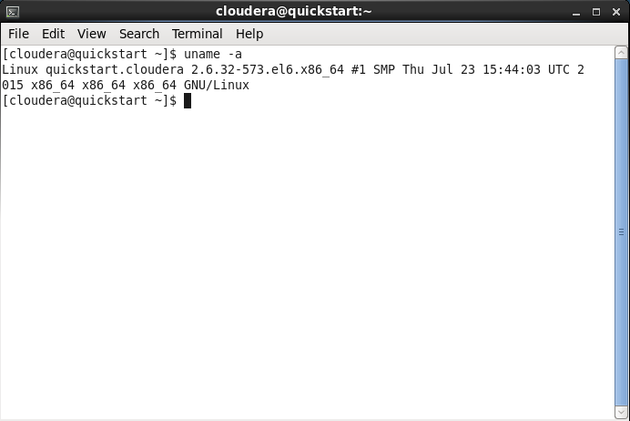

Command 48: echo

The echo command is used to move some data, usually text into a file.
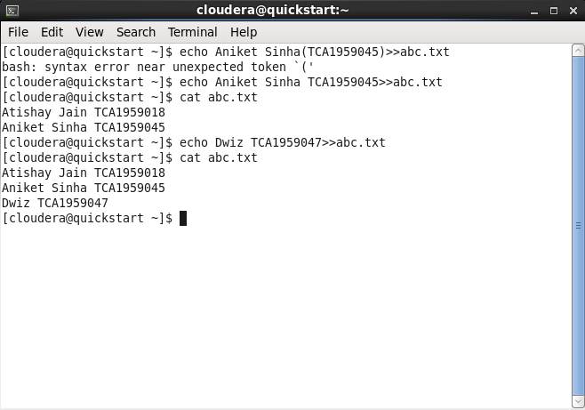

Ques2: - Basic Commands of HDFS.
Answer: -
Command 1: jps
The jps command is used to check the Hadoop services are up and running.
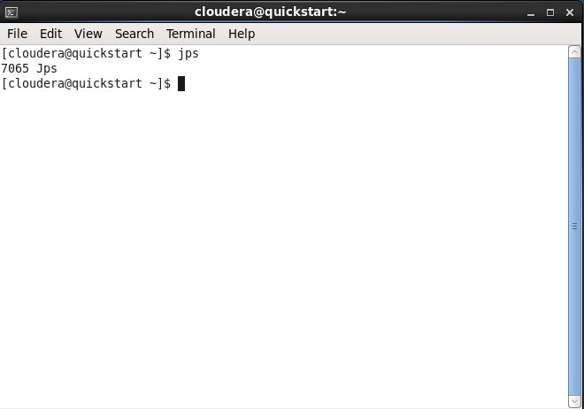
Command 2: mkdir
The mkdir command is used to create a directory.
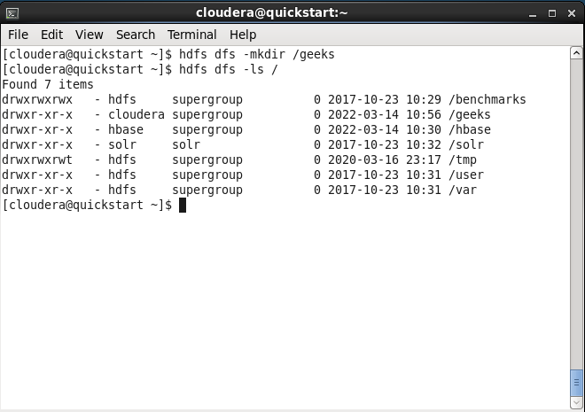

Command 3: touchz
The touchz command is used to create empty file.
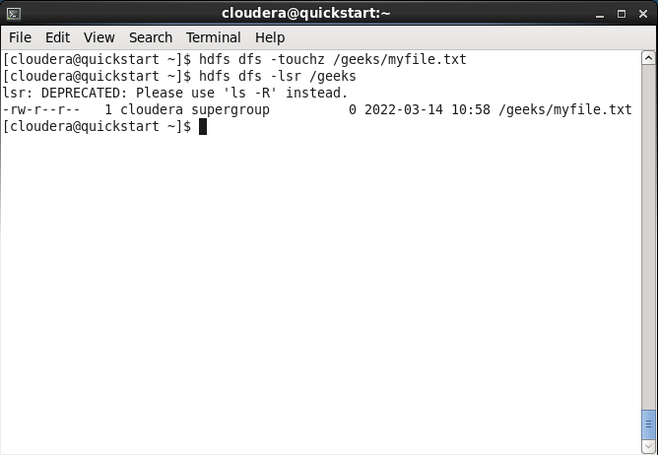
Command 4: copyFromLocal or put
The copyFromLocal or put command is used to copy files/folders from local file system to hdfs store.
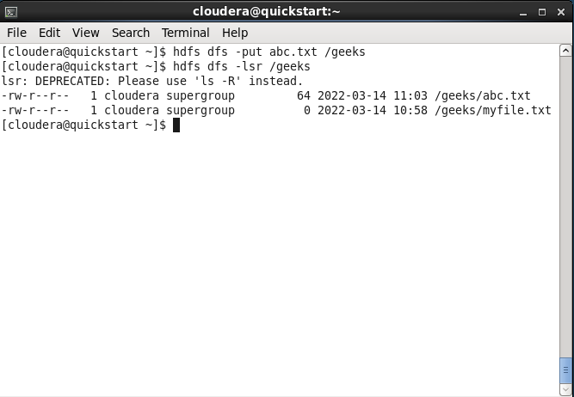
Command 5: cat
The cat command is used to print file contents.
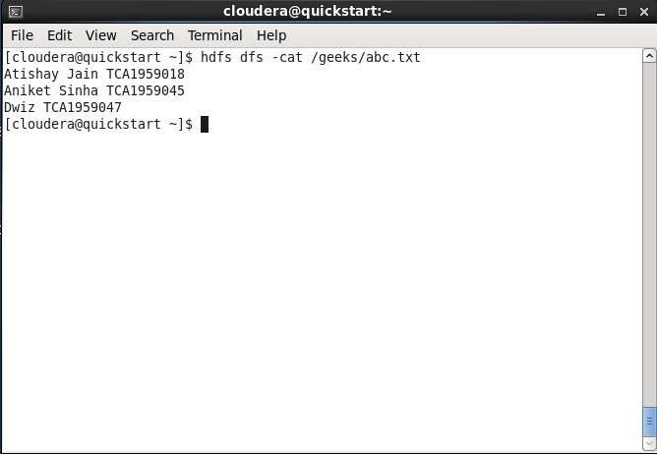
Command 6: copyToLocal or get
The copyToLocal or get is used to copy files/folder from hdfs store to local file system.
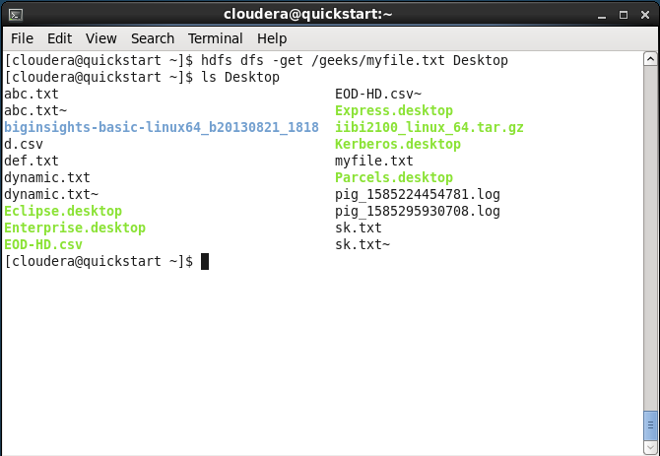
Command 7: moveFromLocal
The moveFromLocal command is used to move file from local to hdfs.
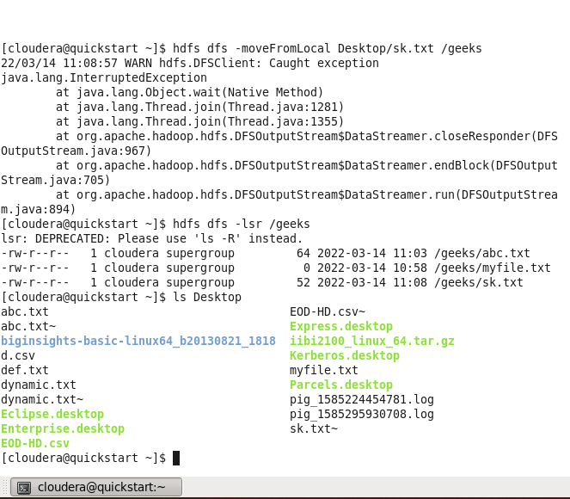
Command 8: cp
The cp command is used to copy files within hdfs.
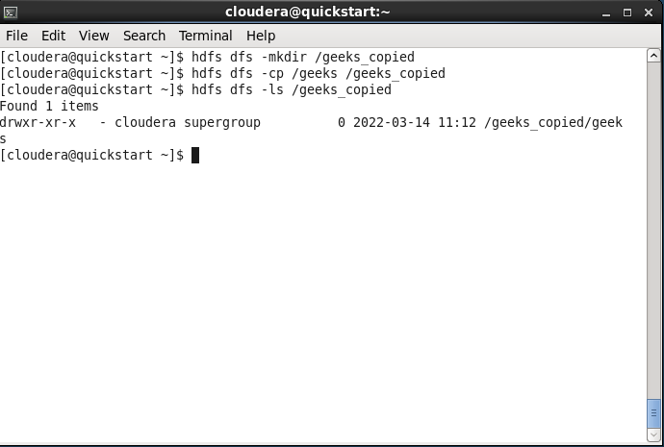
Command 9: du
The du command is used to give size of each file in directory.
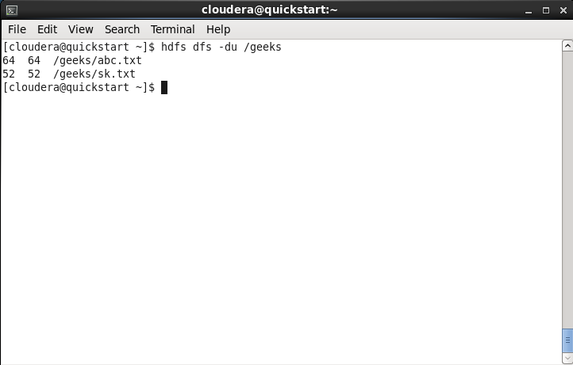
Command 10: mv
The mv command is used to move files within hdfs.
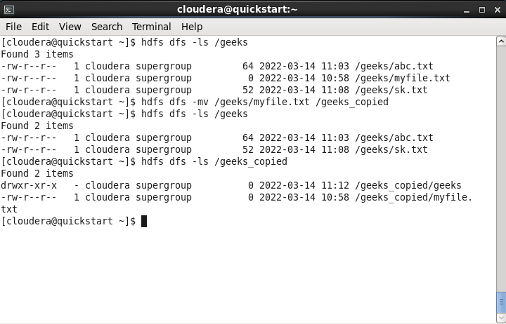
Command 11: rmr
The rmr command is used to delete a file from HDFS recursively
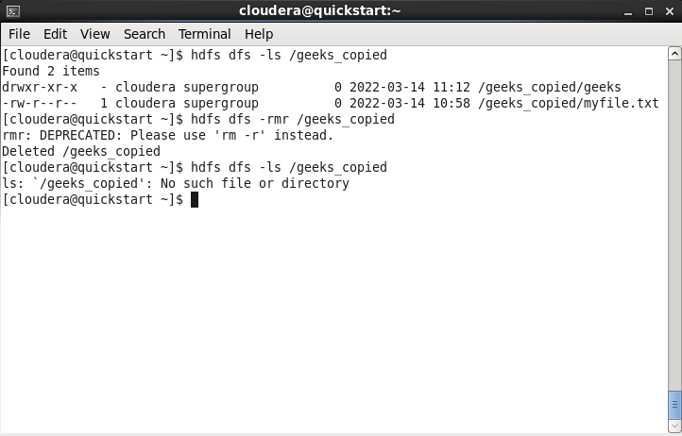
Command 12: dus
The dus command is used give total size of directory/file.
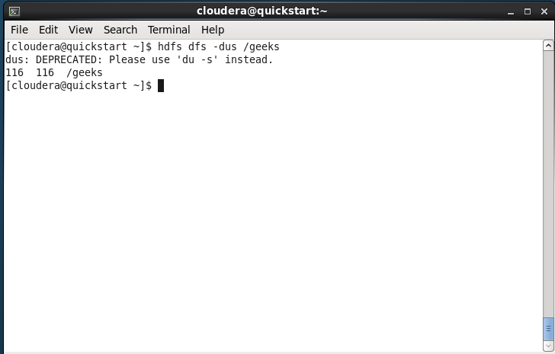
Command 13: stat
The stat command is used to give last modified time of directory or path.
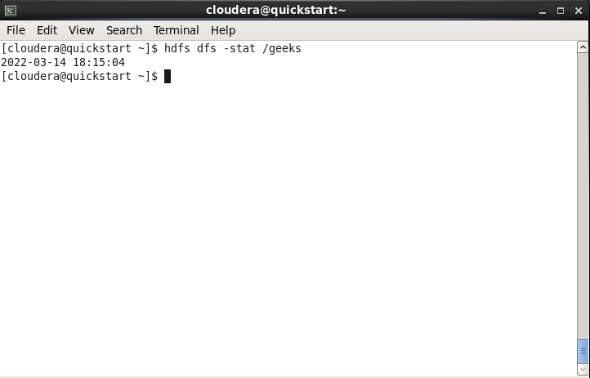
Command 14: setrep
The setrep command is used to change the replication factor of a file/directory in HDFS. By default, it is 3 for anything which is stored in HDFS.
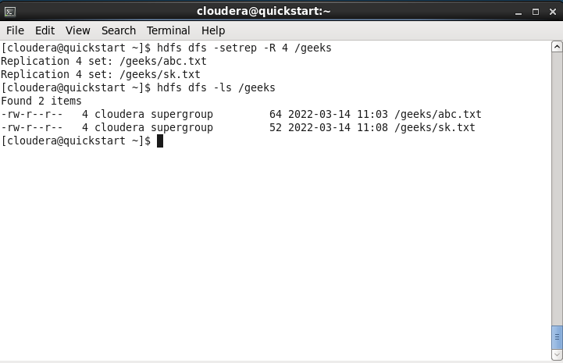
Command 15: hdfs dfs
The hdfs dfs command is used to know more about the commands.
